A Project Report

On

**ESP based Potentiostat**

BY

**Raghav Sigtia**

**2021AAPS2956H**

**&**

**Abhiram Chippa**

**2022AAPS0317H**

Under the supervision of

**Prof. BVVSN Prabhakar Rao**

**SUBMITTED IN PARTIAL FULFILLMENT OF THE REQUIREMENTS OF**

**EEE/ECE/INSTR F376/377: DESIGN PROJECT**



**BIRLA INSTITUTE OF TECHNOLOGY AND SCIENCE PILANI (RAJASTHAN)**

**HYDERABAD CAMPUS**

**(September 2024**)

**ACKNOWLEDGEMENTS**

I would like to express my sincere gratitude to my mentor, Prof. BVVSN Prabhakar Rao and Phd. Scholar Ankit Patil, for guiding and helping us navigate our way through the working of potentiostat, I would also like to extend my gratitude to the authors and contributors of the ESPotensioA Low-Cost and Portable Potentiostat With Multi-Channel and Multi Analysis Electrochemical Measurements paper for providing such a comprehensive segments regarding the project. Their work has enabled us to understand the working and use of ESP microcontroller in potentiostat development for low cost. Additionally, I extend my appreciation to the wider open-source community for their contributions and support, without which this project would not have been possible.



**Birla Institute of Technology and Science-Pilani,**

**Hyderabad Campus**

**Certificate**

This is to certify that the project report entitled “ **ESP based Potentiostat”** submitted by Mr Raghav Sigtia (ID No. 2021AAPS2956H) & Mr. Abhiram Chippa(2022AAPS0317H) in partial fulfillment of the requirements of the course ECE F376, Design Project Course, embodies the work done by him under my supervision and guidance.

**Date: (BVVSN Prabhakar Rao)**

BITS- Pilani, Hyderabad Campus

**CONTENTS**

Title page………………………………………………………………..1

Acknowledgements……………………………………………………..2

Certificate……………………………………………………………….3

1.Introduction……………………………………………….…………..5

2.Materials and Methods………………….…………………………….6

3. Circuit Design and Implementation…………….……………………7

4. Implementation of Cyclic Voltammetry………..…...……………….8

Results and Discussion……….………………………………………..12

References……………………………………………………………..13

**INTRODUCTION**

1. **Brief Overview of Potentiostat**

A potentiostat is an electrochemical instrument used to control and measure the voltage and current in an electrochemical reaction, specifically during redox reactions. It is widely used in analyzing biochemical reactions by controlling the potential between a working electrode and a reference electrode. This allows us to study electron transfer processes, making potentiostats valuable in fields such as biosensing, corrosion studies, and energy storage research. Potentiostats can apply various techniques, like cyclic voltammetry, to examine reaction mechanisms, material properties, and sensor responses.

1. **Why is ESP required?**

We are developing a potentiostat using ESP microcontrollers to make it low-cost, portable, and multi-channel. The ESP-based design allows for wireless communication via Bluetooth, connection with mobile devices, and easy operation using an Android application or a PC-based GUI. This approach significantly reduces production costs, making it affordable for educational, military and clinical settings while retaining high functionality in multiple electrochemical analysis methods​.

**MATERIAL AND METHODS**

Materials Required:

* Microcontroller: ESP32 (Espressif Systems)
* Digital-to-Analog Converter (DAC): MCP4725
* Operational Amplifiers:
* Resistors and Capacitors: 10Kohm and 3.3Kohm resistors and 1uF capacitors used for making the transimpedance amplifiers.
* Voltage Regulators: step-up module(MT3608), negative voltage converter( LM2662).
* Power Source: 4 AA batteries (for portable operation) & USB power supply (for desktop use).
* Software: Arduino IDE (for ESP32 programming)
* Measurement Equipment: Multimeter, oscilloscope.
* Jumper wires for interconnection
* Breadboard for prototyping

**Circuit Design and Implementation**

The architecture of the ESP potentiostat system consists of three main components: the microcontroller, the analog circuitry, and the communication interface. The ESP32 microcontroller controls the voltage and data capture and interacts with the digital-to-analog converter (DAC) and the analog-to-digital converter (ADC). The DAC generates a precise voltage signal that is used for the working electrode in the electrochemical cell, while analog circuits with transimpedance amplifiers convert the current generated by the redox reaction into a measurement voltage. This current-to-voltage conversion allows the ESP32 to read the signal from its ADC and then process and analyze the signal. This efficient and effective operation allows the ESPotensio to achieve success with many channels and many reviews, despite its low cost.

The following is the circuit we are implementing:

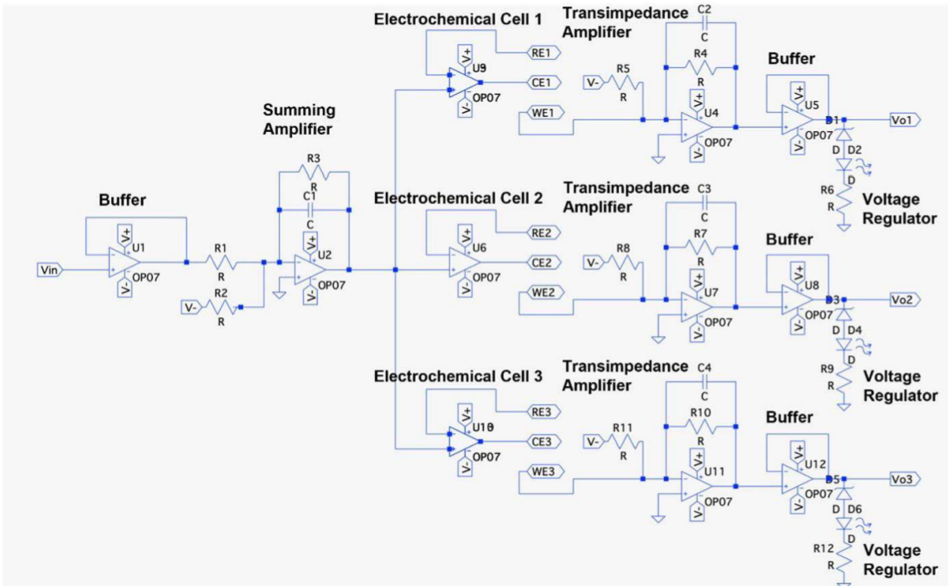

**IMPLEMENTING THE CYCLIC VOLTAMMETRY**

Cyclic voltammetry (CV) is an electrochemical study that focuses on the oxidation-reduction reactions of molecules and any processes occurring on the electrode surfaces. It gives information on the rate of the reactions, their reversibility and the potential limits where such reactions can occur.

In this case, the potential to the working electrode (WE) is a function that ramps to a preset value and then reverses to form a triangular waveform. During this sweep, the current generated by oxidation and reduction reactions at the electrode surface is measured.

As the voltage reaches the redox potential of a species, an electron transfer occurs, causing a current peak. The plot of current vs voltage shows a peak here corresponding to oxidation and reduction reactions, revealing information about the redox behavior, reaction kinetics, and reversibility of the system.

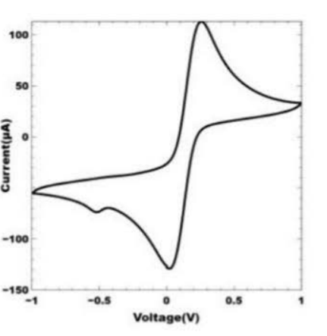

The sample graph that our potentiostat need to obtain

The following code was used to implement the cyclic voltammetry using the ESP32 microcontroller:

#include <Wire.h>

#include <Adafruit_MCP4725.h>

Adafruit_MCP4725 dac;

#define MCP4725_ADDR 0x60 //Address of 12 bit DAC

int adcPin = 34;

float startPotential = 0.0;

float endPotential = 3.0;

float scanRate = 0.1;

float samplingRate = 100;

unsigned long previousMillis = 0;

float stepTime = 1000 / samplingRate;

float voltageStep;

float currentVoltage;

bool reverse = false;

void setup() {

Serial.begin(115200);

if (!dac.begin(MCP4725_ADDR)) {

while (1);

}

pinMode(adcPin, INPUT);

voltageStep = scanRate / samplingRate;

}

void loop() {

unsigned long currentMillis = millis();

if (currentMillis - previousMillis >= stepTime) {

previousMillis = currentMillis;

setVoltageDAC(currentVoltage);

float current = readCurrent();

Serial.print("Voltage (V): ");

Serial.print(currentVoltage, 3);

Serial.print("\tCurrent (A): ");

Serial.println(current, 9);

if (!reverse) {

currentVoltage += voltageStep;

if (currentVoltage >= endPotential) {

reverse = true;

}

} else {

currentVoltage -= voltageStep;

if (currentVoltage <= startPotential) {

reverse = false;

}

}

}

}

void setVoltageDAC(float voltage) {

int dacValue = (int)((voltage / 3.3) * 4095);

dac.setVoltage(dacValue, false);

}

float readCurrent() {

int adcValue = analogRead(adcPin);

float voltage = (adcValue / 4095.0) * 3.3;

float R_feedback = 10000;

float current = voltage / R_feedback;

return current;

}

This code prints the Voltage we are applying to the WE and the current we are detecting.

**Results and Discussion**

So far, we have successfully built the potentiostat circuit using op-amps and connected it to the ESP32. We have also managed to run the voltage sweep for cyclic voltammetry. However, we are encountering an issue with reading the current, as it consistently shows 0 mA.

**References**

* I. F. Ramadhan, I. Anshori, and S. Harimurti, "ESPotensio: A Low-Cost and Portable Potentiostat with Multi-Channel and Multi-Analysis Electrochemical Measurements,"

<https://ieeexplore.ieee.org/abstract/document/9915597>

We used this paper to reference the circuit realized.